**Calculate Electricity Bill**

You have to calculate electricity bill in 8086 Assembly language with the help of procedures and stack. These features are mandatory and carry marks. If you want to add more features to your project then you can add.

Given an integer **U** denoting the amount of KWh units of electricity consumed as input from user, the task is to calculate the electricity bill with the help of the below charges:

* 1 to 100 units – RS. 10/unit
* 100 to 200 units – RS. 15/unit
* 200 to 300 units – RS. 20/unit
* Above 300 units – RS. 25/unit

**Examples:**

**Input:** U = 250  
**Output:** 3500  
**Explanation:**   
Charge for the first 100 units – 10*100 = 1000  
Charge for the 100 to 200 units – 15*100 = 1500  
Charge for the 200 to 250 units – 20*50 = 1000  
Total Electricity Bill = 1000 + 1500 + 1000 = 3500

**Input:** U = 95  
**Output:** 950  
**Explanation:**   
Charge for the first 100 units – 10*95 = 950  
Total Electricity Bill = 950

**Approach:** The idea is to identify the charge bar in which it falls and then calculate the bill according to the charges mentioned above. Below is the illustration of the steps:

* Check units consumed is less than equal to the 100, If yes then the total electricity bill will be:



* Else if, check that units consumed is less than equal to the 200, if yes then total electricity bill will be:

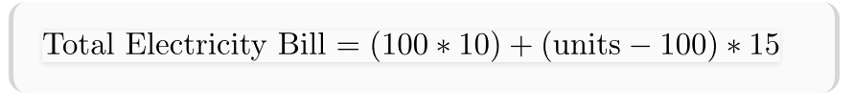

* Else if, check that units consumed is less than equal to the 300, if yes then total electricity bill will be:

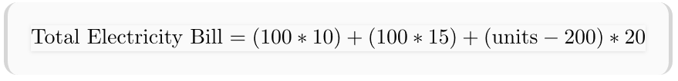

* Else if, check that units consumed greater than 300, if yes then total electricity bill will be:

